PRESS RELEASE

University of Seychelles elected to the presidency of the Regional Conference of Rectors of Southern Africa and the Indian Ocean
The University of Seychelles (UniSey), represented by its Vice-Chancellor, Joëlle Perreau, has been elected to the presidency of the Regional Conference of Rectors of Southern Africa and the Indian Ocean (C2R-AAOI) for the 2027–2028 term, at the regional meeting in Antananarivo, Madagascar. UniSey received 27 out of 31 votes, securing a substantial majority.
This election recognises UniSey’s commitment to regional university cooperation and strengthens Seychelles’ visibility within the French-speaking academic and scientific community. It also reflects the confidence placed in UniSey’s Vice-Chancellor, whose experience and commitment to dialogue between institutions are valuable assets for this collective responsibility.
The C2R brings together rectors, meaning university leaders, also known as Vice-Chancellors in Commonwealth countries such as Seychelles, as well as the heads of other member institutions of the Agence universitaire de la Francophonie (AUF). The AUF’s regional network comprises 45 institutions in nine countries: South Africa, Angola, Comoros, France — through Réunion and Mayotte —, Kenya, Madagascar, Mauritius, Mozambique and Seychelles.
Having served as Vice-President of the C2R since 2023 and subsequently as Acting President, Joëlle Perreau wishes UniSey to advance a shared ambition: to make the Conference a more active platform for cooperation, where exchanges lead to tangible projects benefiting students, researchers and institutions.
Under UniSey’s leadership, the presidency will prioritise academic mobility, joint research, shared training programmes, the pooling of digital resources and the mobilisation of funding. It will also give particular attention to plurilingualism and the region’s complementary expertise, notably in the blue economy, island resilience, innovation, peace and diplomacy.
The University of Seychelles intends to bring institutions together and facilitate cooperation, strengthening links between mainland and island institutions and drawing on the expertise available within the region. Priorities will be developed with member institutions and the AUF, in a spirit of listening, collegiality and responsibility.
Having hosted the Regional Conference of Rectors in September 2024, Seychelles is continuing its commitment to a regional university community that is more united, more visible and more mutually supportive.

Participants in the Regional Conference
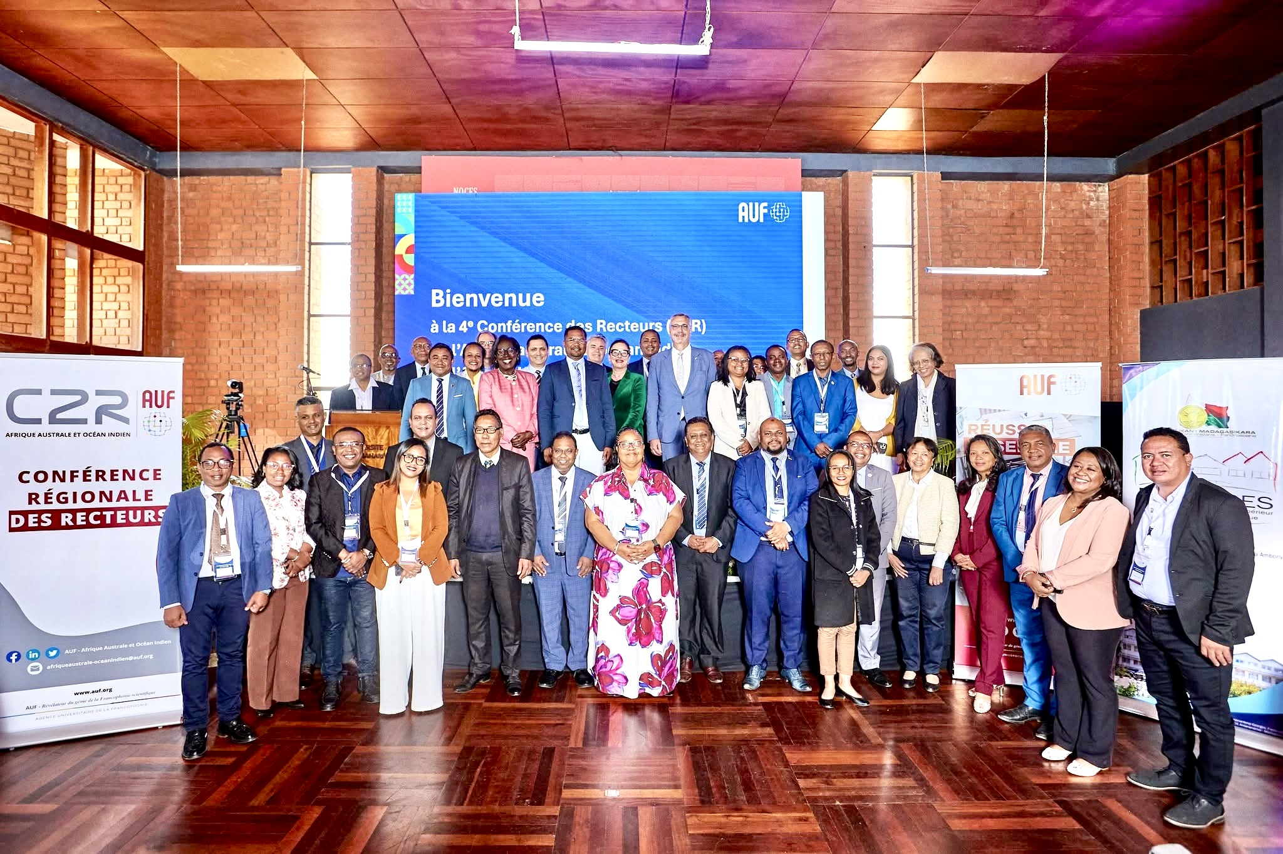
Representatives of member institutions and the Agence universitaire de la Francophonie gathered in Antananarivo, Madagascar, for the fourth Regional Conference of Rectors of Southern Africa and the Indian Ocean, at which the University of Seychelles was elected to the presidency for the 2027–2028 term.

The new Executive Bureau and commission chairs
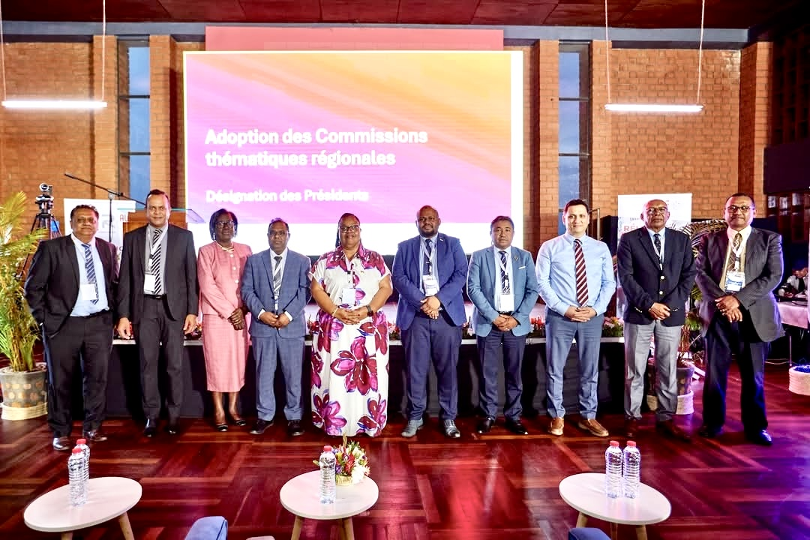
The new C2R-AAOI Executive Bureau and the chairs of the regional thematic commissions, gathered in Antananarivo. Membership announced by the AUF for the 2027–2028 term.
President: Joëlle Perreau, Vice-Chancellor of the University of Seychelles.
Vice-Presidents:
Dinesh Surroop, Director-General of the Open University of Mauritius;
Rivoarison Randrianasolo, President of the Université d’Antananarivo;
Abal-Kassim Cheik Ahamed, President of the Université de Mayotte.
Commission chairs
- Digital technology and AI: Kavi Kumar Khedo, Vice-Chancellor of the University of Mauritius.
- Research, innovation and strategic projects: Dani Osman, Vice-President for Research and Innovation at the Université de La Réunion.
- Peace and conflict management: Luc Rakotondrajaona, Director-General of IST Antananarivo.
- Climate change and sustainable development: Jaona Ranaivoson, Director-General of ISCAM Business School Madagascar.
- Regional mobility: Hemant B. Chittoo, Director-General of the University of Technology Mauritius.

